
THE ACADEMIC SERVICES UNIT
DATA SCIENCE AND INFORMATION TECHNOLOGY SECTION
BACHELOR OF DATA SCIENCE (BDS) YEAR III
TITLE OF PROJECT:
DEVELOPMENT OF A MACHINE LEARNING-BASED CREDIT RISK ASSESSMENT MODEL FOR SME VALUE CHAIN FINANCING:
A CASE STUDY OF TANZANIA'S SUPPLY CHAINS
PARTICIPANTS: GROUP 15
Name 1- Herman Edward Mkumbwa Reg.No: EASTC/BDTS/24/01568
Name 2- Raymond Elphance Tungaraza Reg.No: EASTC/BDTS/24/01082
Name 3- Edwin Celestin Silayo Reg.No: EASTC/BDTS/24/01324
Name 4- Grace Joachim Mohammed Reg.No: EASTC/BDTS/24/01253
Name 5- Priscila Nestor Mpembela Reg.No: EASTC/BDTS/24/01563

Academic Year: 2025/2026

Supervisor’s Name: Mr. Rajabu Msangi Supervisor Signature: ….……………….

Submission Date: 14th July, 2026
TABLE OF CONTENTS
CHAPTER ONE 1
1.0 Introduction 1
1.1 Background 1
1.2 Statement of the Problem 2
1.3 General Objective 2
1.4 Specific Objective 3
1.5 Research Questions 3
1.6 Significance of the Project 3
1.7 Scope of the Project 4
CHAPTER TWO 5
2.0 Literature Review 5
2.1 Definition of key terms 5
2.2 Theoretical framework 6
2.3 Empirical framework 7
2.4 Research gap 8
2.5 Conceptual framework 9
CHAPTER THREE 10
3.0 Methodology 10
3.1 Study Area 10
3.2 Project Approach 10
System Development Dimension & Tools 10
3.3 Population of the Study 11
3.4 Sample size and Sampling Techniques 11
3.5 Sources and Instruments for Data Collection 11
3.6 Data Analysis 11
3.7 Data Preprocessing 12
3.8 Describe models/algorithms/methods used 12
3.9 Model Training & Validation 12
3.10 Deliverables/Output/Results 12
3.11 Ethical Considerations 13
3.12 Timeline for the project 13
CHAPTER FOUR 14
4.0 Project Results and Discussion 14
4.1 Project Results and Interpretation 14
4.2 Pre-processing Results 14
4.3 Project Results 15
4.4 Discussion 15
CHAPTER FIVE 16
5.0 Conclusion and Recommendations 16
5.1 Conclusion 16
5.2 Recommendations 17
5.3 Future Work 17
REFERENCES 18

LIST OF FIGURES.
Fig 1: Project phase/ framework activities timeline………………………………………….13

LIST OF ABBREVIATIONS.
SME - SMALL AND MEDIUM- SIZED ENTERPRISE
ML - MACHINE LEARNING
GDP - GROSS DOMESTIC PRODUCT
B2B - BUSINESS TO BUSINESS
APIs - APPLICATION PROGRAMMING INTERFACES
ERP - ENTERPRISE RESOURCE PLANNING
SQL - STRUCTURED QUERY LANGUAGE
EDA - EXPLORATORY DATA ANALYSIS
ROC - RECEIVER OPERATING CHARACTERISTICS
AUC - AREA UNDER THE CURVE
PII - PERSONALLY IDENTIFIABLE INFORMATION

CHAPTER ONE

1.0 Introduction

1.1 Background
Small and Medium Enterprises (SMEs) are a critical component of Tanzania’s economy, contributing significantly to employment creation, income generation, and national economic growth (World Bank, 2019). According to the Bank of Tanzania (2021), SMEs account for over 35% of the country’s GDP and employ approximately 52% of the working population, underscoring their central role in national economic development.
Despite their importance, access to formal financial services remains a major constraint for SMEs. Many financial institutions rely on traditional credit assessment methods that depend on collateral and formal financial records, which most SMEs lack (Klapper, 2006). This over-reliance on conventional credit frameworks has left millions of creditworthy SMEs outside the reach of formal financing, effectively stalling their potential for growth and innovation.
In Tanzania, a large proportion of SMEs operate within informal or semi-formal environments where structured financial documentation is limited. As a result, financial institutions face difficulties in accurately assessing their creditworthiness, often categorizing them as high-risk borrowers using outdated metrics (Altman, 1968). This creates a financing gap that limits business expansion and innovation. The systemic nature of this challenge is observed globally, with the lack of adequate financial data hindering the development of small enterprises in developing economies (Klapper, 2006).
Recent advancements in data science and machine learning have introduced alternative approaches to credit risk assessment. These approaches leverage non-traditional data such as transaction histories, behavioral patterns, and supply chain interactions to generate more accurate and inclusive credit scores (Khandani et al., 2010). Research has demonstrated that machine learning models, particularly ensemble methods such as Random Forest, can outperform traditional logistic regression models in credit scoring tasks by capturing complex, non-linear relationships within datasets (Breiman, 2001; Lessmann et al., 2015). However, the application of such approaches in Tanzania remains limited, and their integration within supply chain ecosystems is largely unexplored.

Ecosystem banking and value chain financing present an opportunity to integrate financial services within business networks, allowing credit decisions to be based on real-time operational data rather than static financial records (Breiman, 2001). The concept of value chain financing recognizes that SMEs do not operate in isolation but are embedded within networks of buyers, suppliers, and distributors whose interactions generate rich streams of behavioral and transactional data (Klapper, 2006). Despite this potential, there is still a lack of integrated platforms that combine transaction data capture, machine learning, and credit scoring tailored to the Tanzanian context. Bridging this gap requires a purpose-built platform that can capture, process, and interpret supply chain data to generate dynamic and fair credit assessments.

1.2 Statement of the Problem
Despite their critical contribution to the national economy, SMEs in Tanzania face persistent financial exclusion because traditional credit models prioritize collateral and formal financial history assets rarely available to businesses in informal sectors (Klapper, 2006). Current assessment frameworks rely on static, backward-looking financial ratios that fail to account for the dynamic nature of SME operations, often misclassifying viable businesses as high-risk borrowers (Altman, 1968). This reliance on outdated, manual credit evaluation processes creates a severe information asymmetry between SMEs and financial institutions, limiting access to formal credit and stifling growth (Khandani et al., 2010).
Furthermore, the absence of an integrated infrastructure to capture real-time transactional data means that valuable behavioral signals embedded in supply chain interactions remain unutilized (Khandani et al., 2010). Without a platform capable of processing this non-traditional data through machine learning, lenders remain unable to accurately quantify risk, perpetuating the "missing middle" financing gap (Breiman, 2001; Lessmann et al., 2015). There is, therefore, a pressing need to develop an automated, data-driven ecosystem that leverages supply chain insights to provide more accurate, fair, and inclusive credit risk assessments for Tanzanian SMEs (Khandani et al., 2010; Lessmann et al., 2015).

1.3 General Objective
To develop an automated, data-driven ecosystem banking platform that leverages supply chain transaction data and machine learning techniques to provide accurate and inclusive credit risk assessments for SMEs in Tanzania.

1.4 Specific Objective
1. To develop robust data pre-processing and feature engineering pipelines that convert raw supply chain transaction data into predictive variables for SME credit assessment.
2. To evaluate and compare the predictive performance of alternative machine learning algorithms (specifically ensemble techniques) against classical traditional regression benchmarks.
3. To evaluate model performance and predictive reliability using industry-standard metrics to ensure an objective and inclusive credit scoring process.

1.5 Research Questions
1. How can robust data pre-processing and feature engineering pipelines be developed to transform raw supply chain transaction data into predictive variables for SME credit assessment?
2. To what extent do machine learning ensemble techniques significantly improve credit risk classification accuracy for SMEs when compared to traditional classical regression models?
3. How reliable are the predictive outcomes of the trained machine learning models when evaluated using industry-standard performance metrics to ensure an objective credit scoring process?

1.6 Significance of the Project
This study offers significant academic and practical contributions by addressing the systemic challenges of SME financing in Tanzania. Academically, it expands the discourse on financial technology and data science by validating the effectiveness of machine learning for alternative credit scoring within a developing country's unique economic environment (Khandani et al., 2010; Lessmann et al., 2015). Practically, the project introduces a scalable framework that allows financial institutions to evaluate credit risk through real-time supply chain data, effectively bypassing the limitations of traditional, collateral-heavy models (Klapper, 2006).

By digitizing the credit assessment process, this study empowers "unbankable" SMEs, promoting broader financial inclusion and alignment with national economic development targets (Altman, 1968). Furthermore, the platform serves as a blueprint for policymakers and financial innovators, demonstrating how ecosystem banking can transform informal transactional activity into transparent, actionable financial signals (Breiman, 2001).

1.7 Scope of the Project
This study focuses on developing an automated, machine learning-based credit scoring platform to assess SME creditworthiness within the Tanzanian context.
The scope includes:
- Development: Building an end-to-end prototype that integrates data pre-processing, feature engineering, and machine learning classification (Logistic Regression and Random Forest) to generate risk scores (Breiman, 2001; Lessmann et al., 2015).
- Data Analysis: Modelling supply chain relationships using transaction-based datasets to extract meaningful behavioral signals (Khandani et al., 2010).

The study is delimited by the following parameters:
- System Prototype: The project concludes at the prototype stage rather than full-scale market deployment.
- Analytical Constraints: The research is restricted to specific transaction-based features and a defined timeframe for model training and validation (Altman, 1968; Klapper, 2006).

CHAPTER TWO

2.0 Literature Review

2.1 Definition of key terms
Small and Medium Enterprises (SMEs): In Tanzania, SMEs are defined as enterprises engaged in non-farm economic activities such as manufacturing, mining, and trade that fall within specific thresholds for capital investment and number of employees (Ministry of Industry and Trade, 2003; World Bank, 2019). These entities are recognized as critical drivers of national development, contributing significantly to both GDP and employment.
Credit Risk: Defined as the probability that a borrower will fail to fulfil their contractual financial obligations, leading to a loss for the lender (Altman, 1968). This risk is fundamentally tied to the uncertainty of future repayment, often quantified in financial modelling as the probability of default.
Machine Learning (ML): A subfield of artificial intelligence that focuses on the development of algorithms capable of learning patterns from data to perform predictive tasks without being explicitly programmed for each input (Breiman, 2001; Lessmann et al., 2015). In financial contexts, it is increasingly used to improve the accuracy of classification tasks by identifying non-linear relationships that traditional models overlook.
Alternative Credit Scoring: An approach to evaluating creditworthiness that utilizes non-traditional data such as transactional behavior, social media patterns, and supply chain interactions to assess borrowers who lack sufficient formal financial history (Khandani et al., 2010). This method bridges the "information gap" that excludes many SMEs from traditional banking systems.
Ecosystem Banking: A collaborative digital model where financial services are embedded within broader networks of business interactions, allowing for the integration of financial products into the everyday operations of SMEs (Klapper, 2006). This model facilitates access to real-time, high-quality data generated through supply chain relationships.
Feature Engineering: The technical process of selecting, modifying, and transforming raw data inputs to create the most relevant variables for a machine learning model, thereby enhancing its predictive performance and robustness (Khandani et al., 2010).

Value Chain Financing: A finance model that provides credit by analyzing the operational relationships between actors in a supply chain such as buyers, suppliers, and distributors rather than relying on a single firm's static financial records (Klapper, 2006). This approach transforms operational network activity into actionable financial intelligence.
Data Preprocessing: The essential phase of data cleaning and transformation that converts raw, often noisy or inconsistent data into a structured format suitable for machine learning analysis (Khandani et al., 2010). This process includes handling missing values, normalizing data scales, and removing noise to ensure model reliability.
Ensemble Methods: Advanced machine learning techniques that combine the predictions of multiple individual models such as Decision Trees or Random Forests to produce a more accurate and robust final prediction than any single model could achieve independently (Breiman, 2001; Lessmann et al., 2015). By aggregating these predictions, ensemble methods significantly reduce the risk of overfitting in credit scoring applications.

2.2 Theoretical framework
The theoretical framework for this study is grounded in three core pillars that explain the transition from traditional lending to data-driven, alternative credit assessment models.
- Financial Intermediation Theory: This theory highlights the role of financial institutions in reducing information asymmetry between lenders and borrowers (Klapper, 2006). In the context of Tanzanian SMEs, traditional financial intermediation often fails because lenders cannot effectively assess the risk of "informal" borrowers who lack collateral. By integrating supply chain data, this study expands the scope of traditional intermediation, allowing for the inclusion of previously unbankable firms through better information transparency.

- Credit Scoring and Bankruptcy Prediction: The foundational work of Altman (1968) introduced the use of financial ratios to predict corporate bankruptcy, setting the precedent for modern credit scoring. While these traditional models focus on static financial statements, this research builds upon that foundation by integrating machine learning classifiers to evaluate credit risk. This shift moves credit scoring from static, ratio-based analysis to dynamic, pattern-based classification (Khandani et al., 2010).

- Machine Learning and Predictive Modelling: The framework is further supported by learning theory, specifically the application of ensemble models to capture non-linear relationships in data (Breiman, 2001). Research by Lessmann et al. (2015) provides the evidence base for benchmarking these algorithms, demonstrating that ensemble methods such as Random Forest provide superior predictive power compared to classical statistical methods in complex, high-dimensional datasets.
Together, these theories support the development of a platform that transforms raw operational signals into objective, reliable credit risk assessments for SMEs.

2.3 Empirical framework
Recent developments in financial technology have established that transactional data functions as a reliable proxy for SME creditworthiness, particularly for enterprises operating within semi-formal sectors (Khandani et al., 2010). By transitioning from traditional, static financial statement analysis to the examination of continuous operational interactions, financial institutions can effectively mitigate the information asymmetry that historically constrained credit accessibility (Klapper, 2006).
Empirical benchmarking studies provide rigorous evidence that machine learning classifiers offer superior predictive accuracy compared to classical logistic regression models (Lessmann et al., 2015). Research demonstrates that ensemble-based algorithms, such as Random Forest, possess a unique capacity to isolate non-linear patterns within complex, multidimensional supply chain datasets (Breiman, 2001). The efficacy of these predictive models is inherently dependent upon the integrity of the underlying data infrastructure.
Existing literature confirms that systematic data pre-processing specifically the identification and management of missing values, outlier detection, and feature selection is a prerequisite for achieving robust and stable risk classifications (Khandani et al., 2010).

Furthermore, the academic discourse on value chain financing supports the adoption of integrated platforms that move beyond individual firm analysis (Klapper, 2006). Evidence suggests that incorporating multi-party interaction data allows for a more holistic assessment of credit risk, reducing the historical dependence on physical collateral for loan security (Altman, 1968). Recent longitudinal studies also highlight those models trained on non-traditional data are better equipped to adapt to economic volatility, ensuring that risk assessments remain relevant during periods of market instability. These advancements collectively provide a compelling argument for replacing legacy scoring systems with automated, machine-learning-driven alternatives.

2.4 Research gap
Although existing literature validates the efficacy of machine learning in credit scoring and recognizes the potential of value chain financing, several critical gaps persist within the Tanzanian context.
First, there is a notable absence of integrated digital platforms that synthesize machine learning capabilities with real-time transactional data captured from local SME ecosystems. Most current methodologies rely on separate systems for data collection and risk classification, preventing the holistic, real-time assessment required for effective SME lending (Khandani et al., 2010; Klapper, 2006).
Second, there is a scarcity of localized solutions tailored to the unique economic landscape of Tanzania. Existing academic models are frequently benchmarked against developed markets with structured financial datasets, failing to address the complexities of informal transactional behaviors and the lack of traditional financial records inherent in the local SME sector (Altman, 1968; Lessmann et al., 2015).
Finally, the potential of supply chain data as an alternative credit metric remains significantly underutilized. While the theoretical advantages of value chain integration are well documented, few studies have operationalized this by developing purpose-built platforms that extract and interpret these interaction signals (Breiman, 2001). This study addresses these voids by developing an integrated, data-driven prototype that bridges the gap between raw supply chain activity and the rigorous requirements of objective credit risk classification.

2.5 Conceptual framework
The conceptual framework illustrates the flow from raw input to predictive output, demonstrating how an integrated platform transforms supply chain activity into actionable credit insights.
- Input Layer: Data Acquisition: The process begins with the aggregation of heterogeneous operational data. This includes transaction logs, payment histories, and supply chain interaction patterns, which serve as the primary features for the model (Khandani et al., 2010).
- Processing Layer: Feature Engineering: Raw data undergoes rigorous cleaning and transformation to extract behavioral indicators, such as payment consistency and volume trends. This layer mitigates the noise typical of informal sector datasets, ensuring that the model processes high-quality, structured inputs (Breiman, 2001).
- Modelling Layer: Classification: The core of the framework utilizes ensemble machine learning models, specifically Random Forest, to process the engineered features. These models are designed to identify non-linear relationships that traditional financial ratios, such as those described by Altman (1968), cannot detect.
- Output Layer: Credit Assessment: The system generates a dynamic risk classification and a corresponding credit score. This output provides lenders with a clear, objective assessment of an SME's creditworthiness, effectively bypassing the traditional dependence on collateral (Klapper, 2006).

CHAPTER THREE

3.0 Methodology

3.1 Study Area
The study focuses conceptually and geographically on SMEs operating within Tanzania, particularly those involved in supply chain activities such as suppliers, buyers, and distributors. The domain of application is financial technology (FinTech), specifically credit risk assessment and value chain financing within the institutional banking sector facing these challenges. This context is selected due to the systemic credit access barriers faced by Tanzanian SMEs, where a high percentage of businesses lack formal financial records (World Bank, 2019).

3.2 Project Approach
This study adopts a formal deductive research approach executed through a quantitative predictive modeling paradigm. In alignment with deductive inquiry, the study originates from established credit scoring theories and statistical baselines, formulating testable hypotheses regarding the predictive superiority of machine learning algorithms over traditional models.
Rather than relying on exploratory frameworks, this study utilizes empirical, quantitative supply chain transaction datasets to engineer predictive features, train alternative machine learning algorithms, and statistically validate their performance metrics. The final outputs including the predictive credit scoring backend and its functional architecture serve as the empirical validation of the hypothesized framework, ensuring a rigorous, objective, and reproducible quantitative methodology.

System Development Dimension & Tools
The structural framework of the platform prototype is segregated into two primary functional layers:
1. The Backend Analytical Core: Engineered using Python (utilizing libraries such as Pandas, Scikit-Learn, and Stats models) to manage data pipelines, execute alternative feature calculations, and host the trained credit scoring models.
2. The Front-End Interface (User Layer): Built using Vite (html, JavaScript and CSS) to deliver an automated, interactive web dashboard where financial officers and SMEs can visualize scores, view risk metrics, and track transactions in real-time.

3.3 Population of the Study
In accordance with data science project criteria, since this project is thoroughly data-centric, the population refers to the complete collection of transactions, business data logs, user interactions, or events recorded within the target supply chain networks. Conceptually, the population comprises the historical aggregate of all B2B transactional footprints generated within the partner distribution channels in Tanzania.

3.4 Sample size and Sampling Techniques
Due to computational boundaries, security filters, or data-sharing agreements with platform stakeholders, a selective sampling technique is used. The study samples a dedicated subset of transaction records covering a continuous operational timeframe. The specific sample size consists of thousands of distinct transaction records filtered to ensure adequate representation of payment anomalies, default instances, and standard compliance variations across sample periods.

3.5 Sources and Instruments for Data Collection
Data collection leverages automated digital pipelines, including Application Programming Interfaces (APIs) and structural transaction logs extracted directly from supply chain ERP systems, digital wallets, or merchant portals.
- Data Fields Collected: Order records, invoice fulfillment times, historical payment default indicators, account age, turnover volumes, and transaction frequencies.
- Data Security and Storage: Collected data is pseudonymized and stored securely in a relational database engine (SQL) to defend privacy rights and comply with ethical data governance practices.

3.6 Data Analysis
The data analysis track is systematically split into data preprocessing, descriptive modeling, predictive modeling execution, and metric validation to answer the research questions.

3.7 Data Preprocessing
Using Python data tools, the raw, noisy, or incomplete transactional files undergo structural scrubbing.
This involves:
1. Handling Missing Data & Outliers: Missing records are imputed using statistical means or median trends, and anomalous spikes are isolated.
2. Exploratory Data Analysis (EDA): Executed using Seaborn and Plotly to visualize hidden correlations and discover transactional density patterns.
3. Feature Scaling: Continuous numeric values are standardized using min-max scaling or standard normalization to stabilize classification engines.

3.8 Describe models/algorithms/methods used
To solve the credit prediction classification task, the platform maps features using two core machine learning approaches:
1. Baseline Classification Model (Logistic Regression): Implemented to establish a clear, linear statistical threshold for risk parsing.
2. Advanced Ensemble Method (Random Forest Classifier): Implemented as the primary predictive engine to successfully untangle complex, non-linear dependencies across multi-party transaction streams.

3.9 Model Training & Validation
The structured dataset is partitioned into an 80/20 train-test split. Models are tuned utilizing k-fold cross-validation methods to guarantee out-of-sample performance consistency and suppress model overfitting risks. Predictive reliability and performance are benchmarked using key data science metrics, including the Area Under the Receiver Operating Characteristic curve (ROC-AUC), Accuracy, Precision, Recall, and F1-score.

3.10 Deliverables/Output/Results
The definitive project deliverables encompass:
• An operational machine learning backend pipeline capable of evaluating alternative data inputs.
• A functional, deployment-ready interactive frontend dashboard web portal (Vite prototype) for real-time dynamic credit scoring visualization.
• A comprehensive project technical performance validation report detailing accuracy yields and analytical constraints.

3.11 Ethical Considerations
Strict ethical compliance is maintained: all collected transactional records are fully anonymized to remove personally identifiable information (PII) before modeling. Data security storage rules are observed to prevent exposure, ensuring the project aligns perfectly with fair financial data management guidelines.

3.12 Timeline for the project
• Phase 1: Problem Definition & Resource Gathering: Week 1–2
• Phase 2: Target Framework Architecture & Data Engineering Pipelines: Week 3–5
• Phase 3: Model Development & Algorithm Training: Week 6
• Phase 4: Algorithmic Verification, Benchmarking & Dashboard Integration: Week 7–12
• Phase 5: Performance Documentation & Final Evaluation Report Assembly: Week 13–15
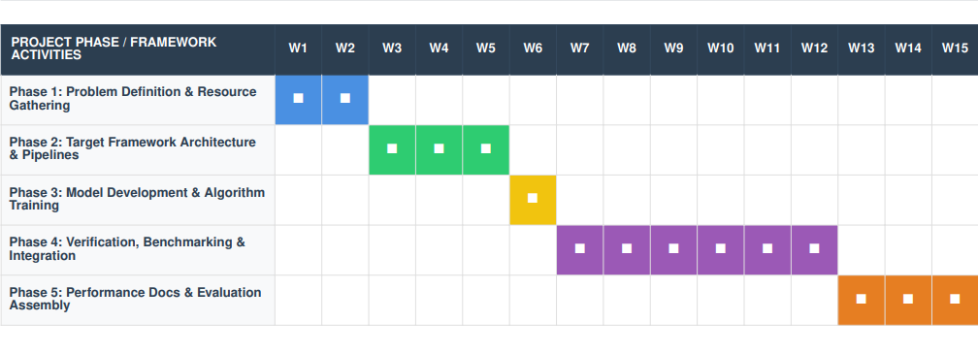
Fig 1: Project phase/ framework activities timeline.

CHAPTER FOUR

4.0 Project Results and Discussion
This chapter presents the outcomes of the machine learning-based credit risk assessment model developed for SME value chain financing in Tanzania. The results are discussed in relation to the project objectives: data preprocessing and feature engineering, model comparison, and model performance evaluation.

4.1 Project Results and Interpretation
The project successfully produced and deployed a predictive credit scoring prototype that uses supply chain transaction data to classify SME credit risk. The analytical pipeline transforms uploaded or manually recorded transactions into structured behavioural variables. After an SME records at least five transactions, the system generates a credit score, risk band, creditworthy probability, explainable signals, and an indicative financing amount for SME and lender decision support.
The findings show that supply-chain transaction behaviour can support alternative assessment of SMEs that lack sufficient collateral or audited financial statements. This is important in the Tanzanian context, where viable informal and semi-formal businesses may be excluded by traditional evaluation. The deployed Ushirika portal operationalises this approach through separate bilingual workspaces for SMEs, lenders, administrators, and sub-administrators.
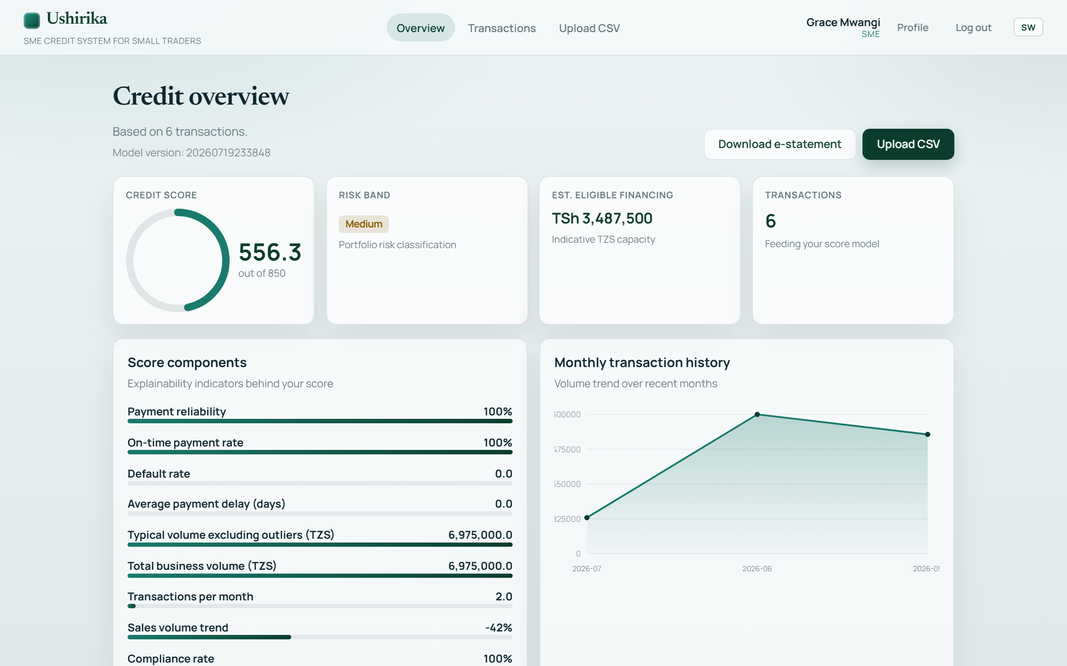
Figure 4.1: SME credit overview showing the ML credit score, risk band, eligible financing, and score components.

Figure 4.2: Ushirika authentication screen (secure ID and PIN login).

4.2 Pre-processing Results
The preprocessing stage cleaned and prepared transaction data by validating required values, handling missing values, converting dates and amounts, normalising categorical values, and detecting unusual transactions. Numerical gaps were filled using median imputation, noisy continuous values were controlled using interquartile-range clipping, and the train/test process was stratified to preserve class balance. The platform accepts both English and Kiswahili CSV templates and manual transaction entry; counterparty TIN is optional because some informal buyers and suppliers do not possess one.
Feature engineering converted raw transaction activity into predictive variables that reflect SME behaviour. These included payment reliability, average and maximum delay, transaction volume and frequency, account age, order completion, default and compliance rates, partner diversity, sales trend, on-time payment rate, intervals between transactions, buyer/supplier shares, and order-type mix. Rare high-value transactions were flagged so that a single unusual invoice would not inflate the indicative financing amount.
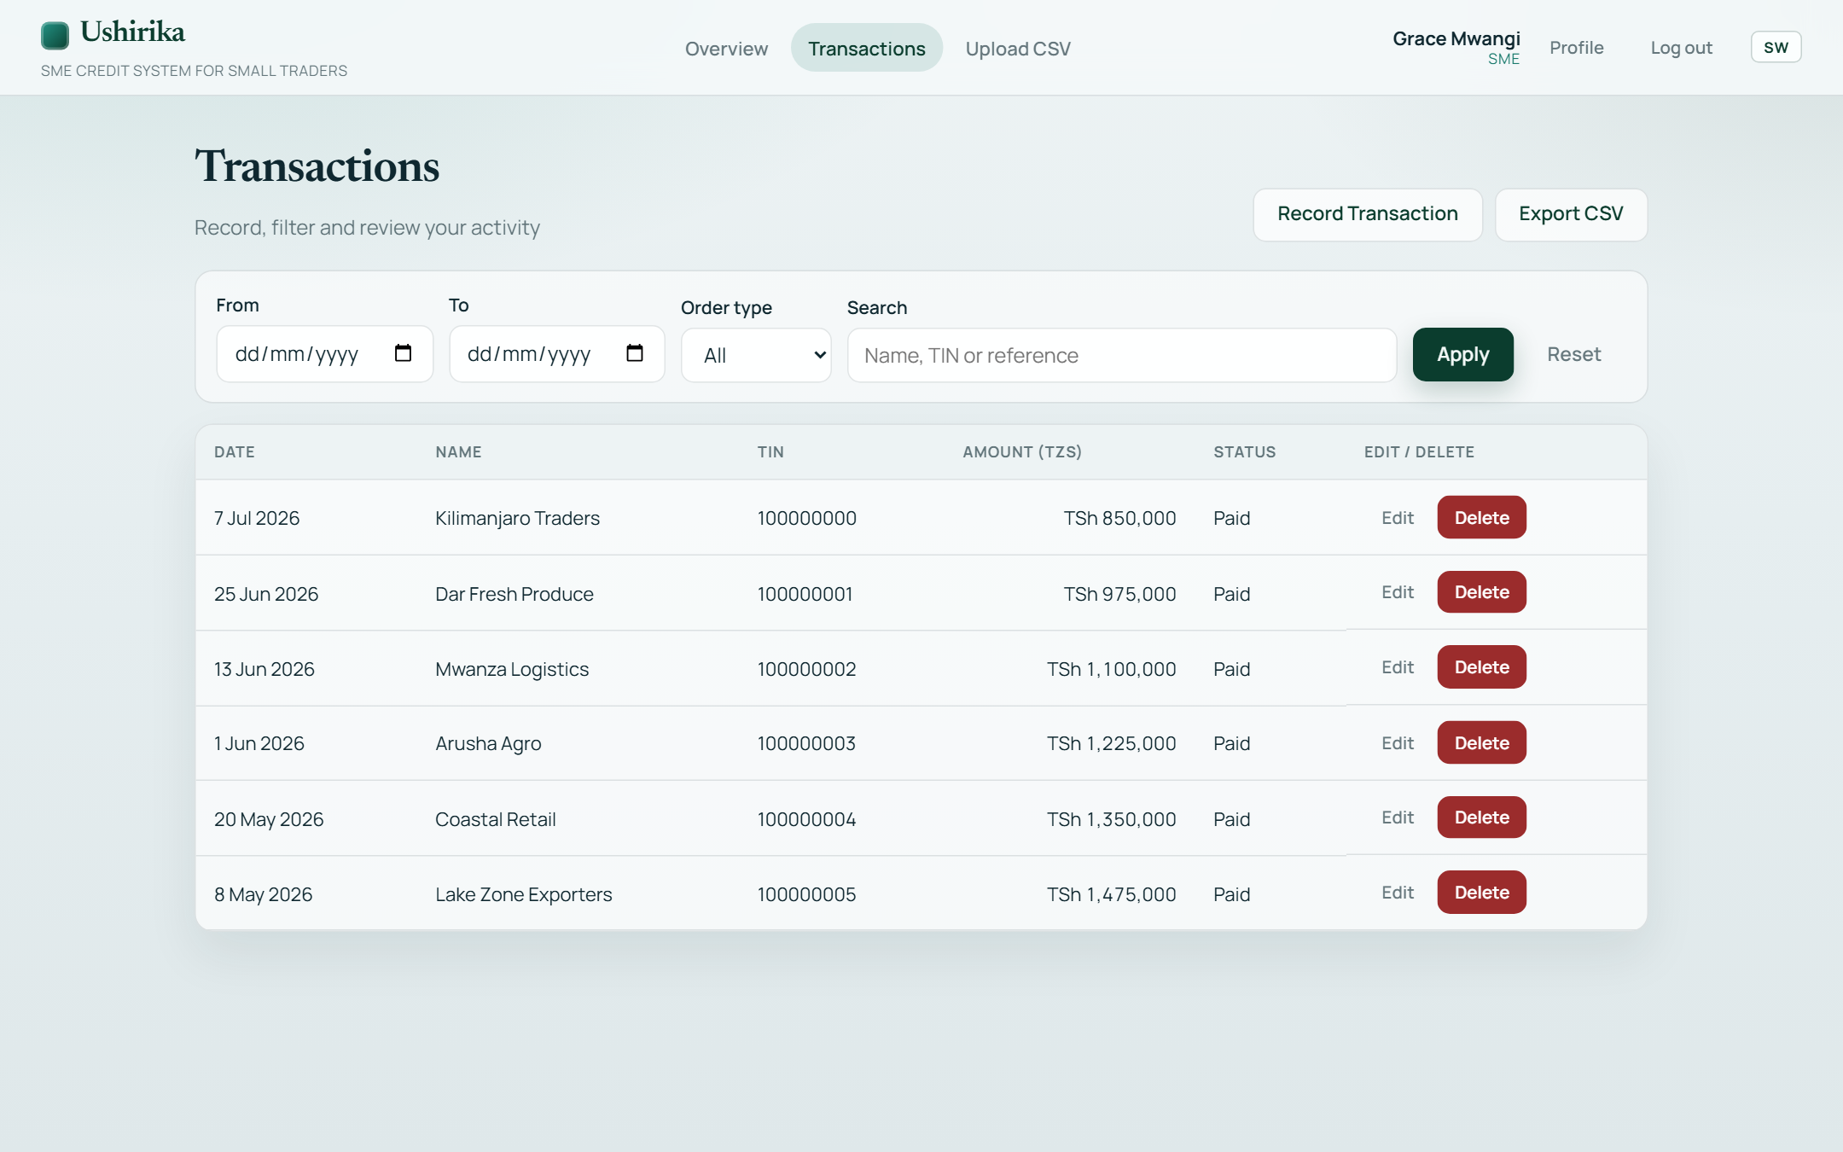
Figure 4.3: SME transaction register providing supply-chain activity used for feature engineering.

Figure 4.4: CSV upload interface for importing transactional statements into the preprocessing pipeline.

4.3 Project Results
The first specific objective was achieved. The implemented preprocessing and feature engineering pipeline transforms raw supply-chain transactions into seventeen behavioural predictors and outlier indicators. The same pipeline is used when SMEs upload a CSV file or record transactions manually, thereby connecting the analytical method directly to the working system.
The second specific objective was achieved by comparing Logistic Regression as the classical baseline with Random Forest as the ensemble model on the same stratified 80:20 train/test split. On the hold-out test data, Random Forest achieved 88.6% accuracy, 93.0% precision, 85.7% recall, 89.2% F1-score, and 95.8% ROC-AUC. Logistic Regression achieved 77.9% accuracy, 75.8% precision, 87.7% recall, 81.3% F1-score, and 87.5% ROC-AUC. Random Forest was therefore selected as the primary scorer because it provided the stronger overall discrimination and classification balance.
The third specific objective was achieved through hold-out accuracy, precision, recall, F1-score, ROC-AUC, and confusion-matrix evaluation. Five-fold GridSearchCV was applied on the training portion using ROC-AUC as the selection measure, while the final metrics were calculated on unseen test data. These controls, together with a minimum of five transactions before scoring and conservative score and financing rules, provide a transparent basis for interpreting the prototype's predictions.

Figure 4.5: Lender list of SMEs with risk classification, credit scores, and NIDA search.

Figure 4.6: Lender SME detail profile (including TIN) with tabbed ML analytics.
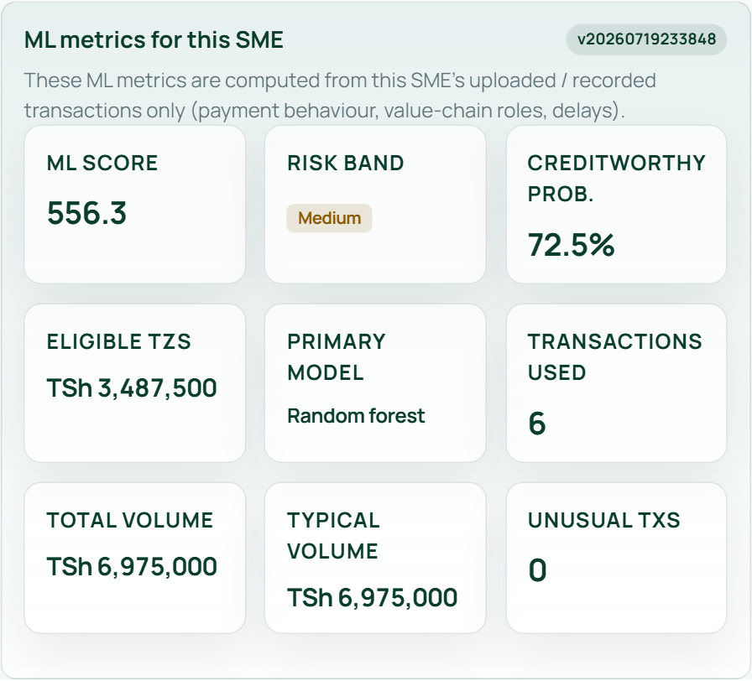
Figure 4.7: ML metrics panel for a selected SME (score, risk, probability, and financing).
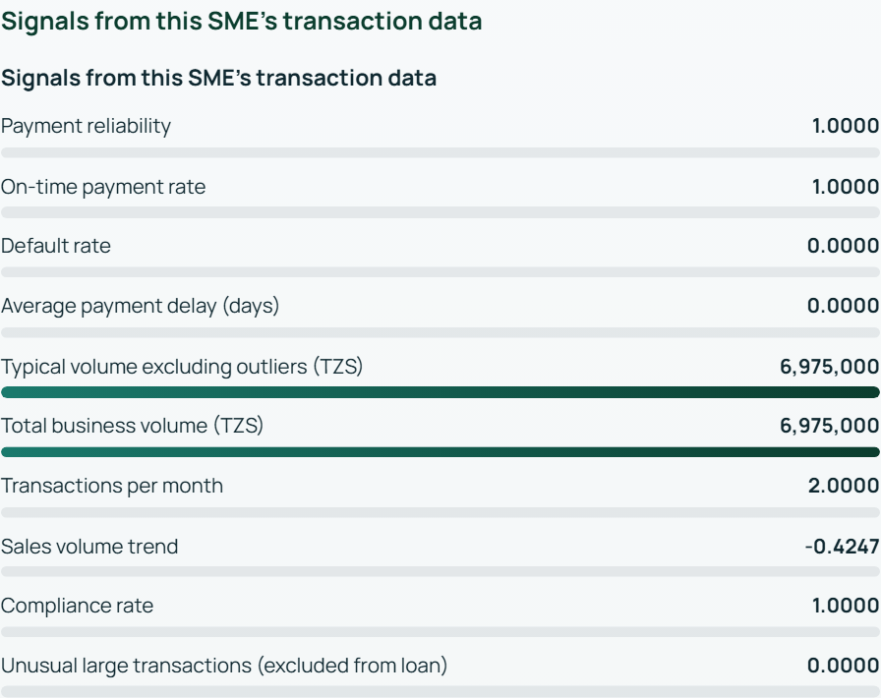
Figure 4.8: Explainable score signals derived from the SME’s engineered features.

4.4 Discussion
The overall findings support the suitability of machine learning for alternative SME credit assessment where conventional financial information is limited. The stronger Random Forest ROC-AUC of 95.8%, compared with 87.5% for Logistic Regression, indicates that non-linear relationships in payment behaviour, volume, delays, and value-chain roles were useful for ranking risk in the evaluated data. However, the result should be interpreted as prototype evidence rather than proof of performance across all Tanzanian SMEs.
The Random Forest result is consistent with Breiman (2001) and Lessmann et al. (2015), who demonstrate the value of ensemble methods for complex classification and credit-scoring tasks. The use of transaction behaviour as an alternative signal also agrees with Khandani et al. (2010), while the inclusion of buyer-supplier relationships reflects the value-chain financing perspective discussed by Klapper (2006). The project contributes by converting these ideas into a working Tanzanian SME credit-risk prototype rather than presenting only a theoretical model.
Although the prototype is deployed online and its core workflows are operational, it is not yet a bank-production system. The training evidence still depends partly on synthetic bootstrap data and engineered labels because sufficiently large longitudinal repayment datasets from Tanzanian SMEs were not available. Transaction quality, sparse histories, free-tier cloud cold starts, and the absence of formal integration with national identity, banking, ERP, and credit-bureau systems may affect operational reliability and generalisability.

Figure 4.9: Admin governance screen for managing SME and lender accounts in the prototype.
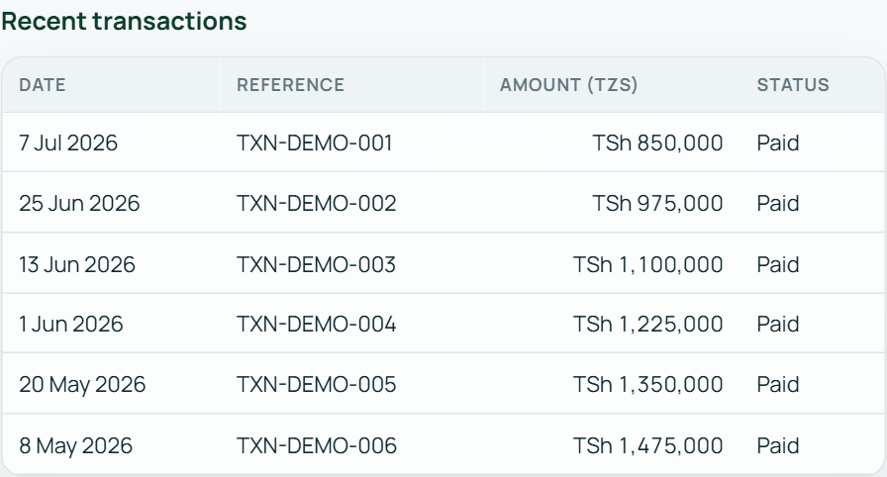
Figure 4.10: Recent transactions view used by lenders when reviewing an SME’s repayment behaviour.

CHAPTER FIVE

5.0 Conclusion and Recommendations

5.1 Conclusion
The project set out to develop an automated machine learning-based credit risk assessment system for SME value chain financing in Tanzania. Its main objectives were to build preprocessing and feature engineering pipelines, compare ensemble and classical models, and evaluate predictive performance using standard metrics.
The study concludes that the proposed approach can improve SME credit assessment by supplementing collateral-heavy methods with data-driven analysis of supply-chain behaviour. The findings demonstrate that transaction data provides useful indicators of payment reliability, trading activity, delays, partner diversity, and order completion, especially for informal or semi-formal businesses with limited conventional records.
The development process confirmed that data preparation is as important as modelling. Under the evaluated protocol, Random Forest performed better overall than Logistic Regression, particularly in accuracy, F1-score, and ROC-AUC. The conclusion is therefore limited to the evaluated dataset and protocol, but it supports the selection of Random Forest as the primary model for the current prototype.
The system is applicable as a deployed prototype for financial institutions, fintech developers, and policymakers interested in financial inclusion. Its bilingual SME, lender, administrator, and sub-administrator dashboards demonstrate the complete workflow from account management and transaction capture to scoring and lender review. Its usefulness nevertheless remains constrained by data availability, data quality, prototype hosting, and the need for supervised pilots using observed repayment outcomes.

Figure 5.1: Admin create-lender form illustrating operational readiness of the deployed prototype.

5.2 Recommendations
Financial institutions should pilot data-driven credit assessment that incorporates supply-chain transaction behaviour alongside, rather than immediately replacing, existing affordability, identity, and compliance checks. A phased pilot in one value-chain sector would allow lenders to compare Ushirika scores with observed repayment outcomes before wider adoption.
Authorities and lending organisations should invest in secure digital record keeping, consent-based data sharing, and common transaction standards. Production implementation should integrate verified NIDA services, managed database infrastructure, ERP systems, digital wallets, merchant platforms, and auditable access controls while complying with applicable Tanzanian data-protection requirements.
Before production use, the model should be validated on larger longitudinal datasets covering different SME sectors and regions of Tanzania. Evaluation should include fairness across groups, calibration, model drift, false-positive and false-negative costs, security testing, and independent human review of lending decisions.

5.3 Future Work
Future research should collect longitudinal transaction and observed repayment-outcome data, then compare Random Forest with gradient boosting, XGBoost, and other suitable algorithms under local Tanzanian SME conditions. Explainability methods such as SHAP and ongoing model-drift monitoring should also be evaluated before production adoption.
Because a web-based scoring platform, role-based dashboards, bilingual forms, CSV import, and explainable score signals have already been implemented, future work should focus on production hardening rather than basic interface development. Priorities include managed PostgreSQL, verified identity services, multi-factor recovery, automated lender alerts, ERP and payment integrations, continuous model audit, and monitored pilots with partner financial institutions.

REFERENCES
Altman, E. I. (1968). Financial ratios, discriminant analysis and the prediction of corporate bankruptcy. The Journal of Finance, 23(4), 589–609. https://doi.org/10.1111/j.1540-6261.1968.tb00843.x
Bank of Tanzania. (2021). Annual Economic Report on Small and Medium Enterprise Financing and Economic Growth in Tanzania. BOT Printers.
Breiman, L. (2001). Random forests. Machine Learning, 45(1), 5–32. https://doi.org/10.1023/A:1010933404324
Hevner, A. R., March, S. T., Park, J., & Ram, S. (2004). Design science in information systems research. MIS Quarterly, 28(1), 75-105.
Khandani, A. E., Kim, A. J., & Lo, A. W. (2010). Consumer credit-risk models via machine-learning algorithms. Journal of Banking & Finance, 34(11), 2767–2787. https://doi.org/10.1016/j.jbankfin.2010.06.001
Klapper, L. (2006). The role of factoring for financing small and medium enterprises. Journal of Banking & Finance, 30(11), 3111–3130. https://doi.org/10.1016/j.jbankfin.2006.05.014
Lessmann, S., Baesens, B., Seow, H.-V., & Thomas, L. C. (2015). Benchmarking state-of-the-art classification algorithms for credit scoring. European Journal of Operational Research, 247(1), 124–136. https://doi.org/10.1016/j.ejor.2015.05.030
Ministry of Industry and Trade. (2003). Small and Medium Enterprise Development Policy. Government Printers, Dar es Salaam, Tanzania.
Peffers, K., Tuunanen, T., Rothenberger, M. A., & Chatterjee, S. (2008). A design science research methodology for information systems research. Journal of Management Information Systems, 24(3), 45-77.
World Bank. (2019). Tanzania Economic Update: Empowering SMEs for Financial Inclusion and Job Creation. World Bank Group.

